Audio-Technica Kit

0

- Audio-Technica Microphone
S/N 42005170210
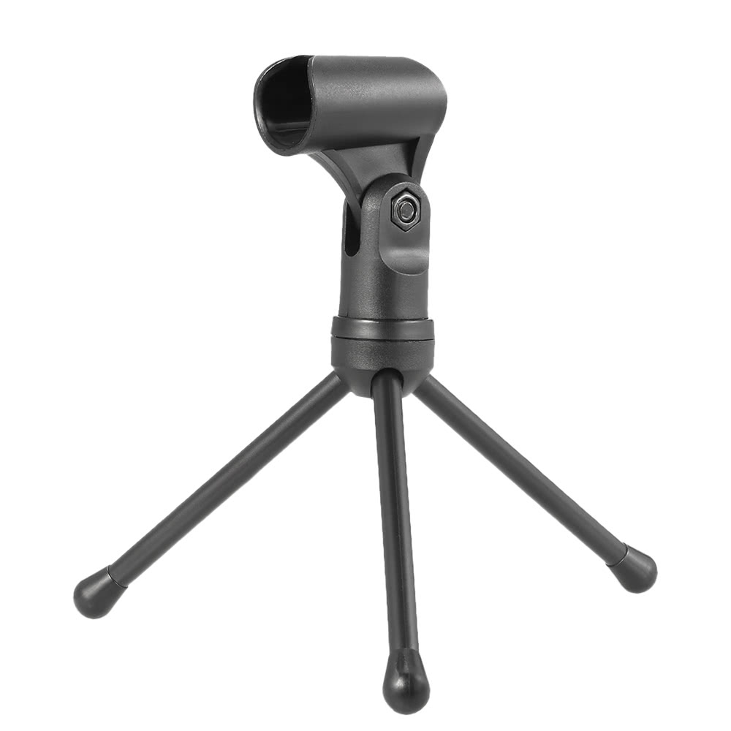
- Tripod
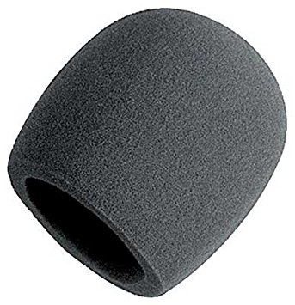
- Windshield
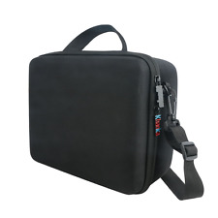
- Black Case
- Instruction Manual
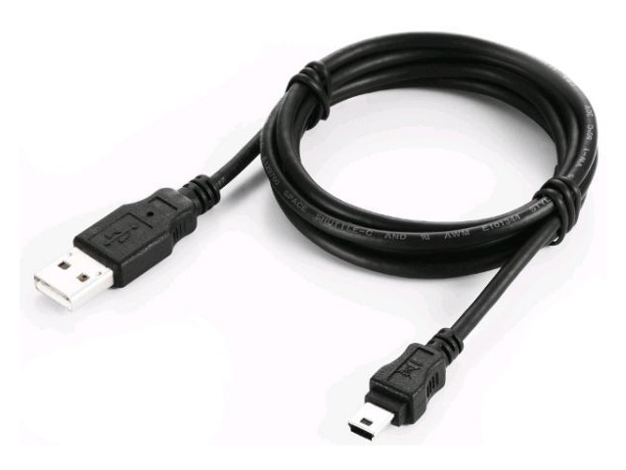
- USB Cable
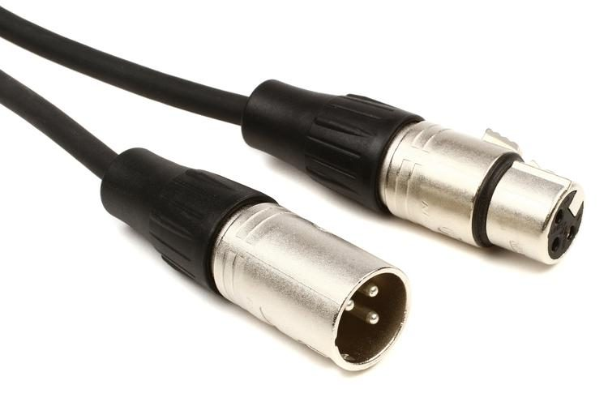
- XLR Cable
- iPhone and Android Adapters
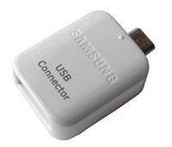
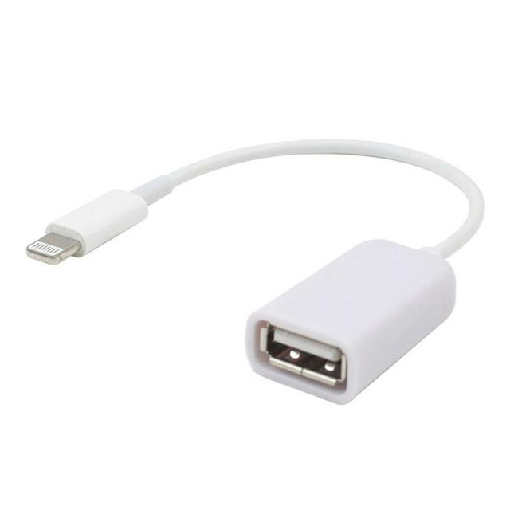

*PLEASE ENSURE ALL ITEMS ARE IN THE KIT BEFORE RETURNING!

Kit #1
Kit #1
Audio-Technica Kit
0

- Microphone Audio-Technica
S/N 42005170210
- Trépied
- Pare-Brise
- Caisse Noir
- Mode D’Emploi
- Cable USB
- Cable XLR
- Adaptateurs iPhone et Android
Kit #1
Kit #1

*PLEASE ENSURE ALL ITEMS ARE IN THE KIT BEFORE RETURNING!
*PLEASE ENSURE ALL ITEMS ARE IN THE KIT BEFORE RETURNING!

